Logistic Regression in Machine Learning

* + Logistic regression is one of the most popular Machine Learning algorithms, which comes under the Supervised Learning technique. It is used for predicting the categorical dependent variable using a given set of independent variables.
  + Logistic regression predicts the output of a categorical dependent variable. Therefore the outcome must be a categorical or discrete value. It can be either Yes or No, 0 or 1, true or False, etc. but instead of giving the exact value as 0 and 1, **it gives the probabilistic values which lie between 0 and 1**.
  + Logistic Regression is much similar to the Linear Regression except that how they are used. Linear Regression is used for solving Regression problems, whereas **Logistic regression is used for solving the classification problems**.

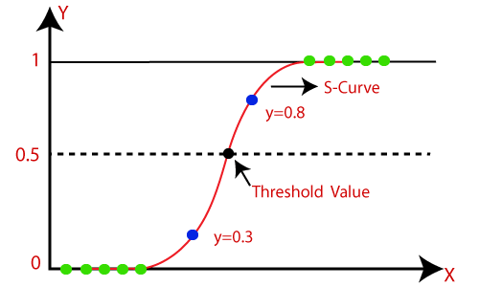

K-Means

K-Means Clustering Algorithm

K-Means Clustering is an unsupervised learning algorithm that is used to solve the clustering problems in machine learning or data science. In this topic, we will learn what is K-means clustering algorithm, how the algorithm works, along with the Python implementation of k-means clustering.

What is K-Means Algorithm?

K-Means Clustering is an [Unsupervised Learning algorithm](https://www.javatpoint.com/unsupervised-machine-learning), which groups the unlabeled dataset into different clusters. Here K defines the number of pre-defined clusters that need to be created in the process, as if K=2, there will be two clusters, and for K=3, there will be three clusters, and so on.

It is an iterative algorithm that divides the unlabeled dataset into k different clusters in such a way that each dataset belongs only one group that has similar properties.

It allows us to cluster the data into different groups and a convenient way to discover the categories of groups in the unlabeled dataset on its own without the need for any training.

It is a centroid-based algorithm, where each cluster is associated with a centroid. The main aim of this algorithm is to minimize the sum of distances between the data point and their corresponding clusters.

The algorithm takes the unlabeled dataset as input, divides the dataset into k-number of clusters, and repeats the process until it does not find the best clusters. The value of k should be predetermined in this algorithm.

The k-means [clustering](https://www.tpointtech.com/clustering-in-machine-learning) algorithm mainly performs two tasks:

* Determines the best value for K center points or centroids by an iterative process.
* Assigns each data point to its closest k-center. Those data points which are near to the particular k-center, create a cluster.

Hence each cluster has datapoints with some commonalities, and it is away from other clusters.

The below diagram explains the working of the K-means Clustering Algorithm:

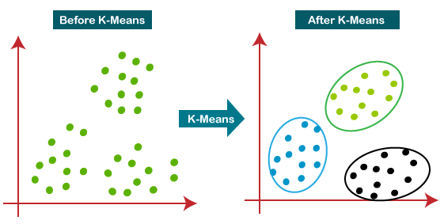

Hierarchical Clustering

Hierarchical Clustering in Machine Learning

Hierarchical clustering is another unsupervised machine learning algorithm, which is used to group the unlabeled datasets into a cluster and also known as **hierarchical cluster analysis** or HCA.

In this algorithm, we develop the hierarchy of clusters in the form of a tree, and this tree-shaped structure is known as the **dendrogram**.

Agglomerative Hierarchical clustering

The agglomerative hierarchical clustering algorithm is a popular example of HCA. To group the datasets into clusters, it follows the **bottom-up approach**. It means, this algorithm considers each dataset as a single cluster at the beginning, and then start combining the closest pair of clusters together. It does this until all the clusters are merged into a single cluster that contains all the datasets.

This hierarchy of clusters is represented in the form of the dendrogram.

Woking of Dendrogram in Hierarchical clustering

The dendrogram is a tree-like structure that is mainly used to store each step as a memory that the HC algorithm performs. In the dendrogram plot, the Y-axis shows the Euclidean distances between the data points, and the x-axis shows all the data points of the given dataset.

The working of the dendrogram can be explained using the below diagram:

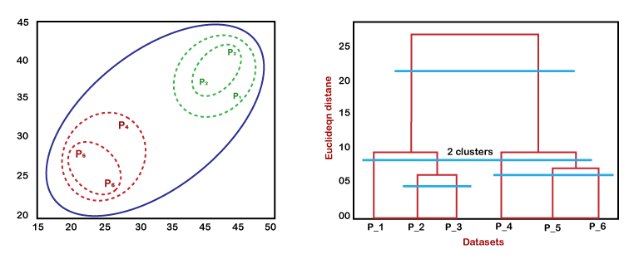

Elbow method

Choosing the optimal number of clusters is a crucial step in any unsupervised learning algorithm. Since we don’t have predefined cluster counts in unsupervised learning, we need a systematic approach to determine the best k value. The **Elbow Method** is a popular technique used for this purpose in K-Means clustering.